H.T No
Regulations:
A22

Sreenidhi Institute of Science and Technology
(An Autonomous Institution)
Code No:9EC13 Date:07-July-2025 (AN)

B.Tech III-Year II- Semester External Examination, July-2025 (Regular)
ARTIFICIAL INTELLIGENCE AND DEEP LEARNING (CSE, IT AND ECM)

Time: 3 Hours Max.Marks:60

Note: a) No additional answer sheets will be provided.
b) All sub-parts of a question must be answered at one place only, otherwise it will not be valued.
c) Missing data can be assumed suitably.
Bloom's Cognitive Levels of Learning (BCLL)

Remember | L1 | Apply | L3 | Evaluate | L5
Understand | L2 | Analyze | L4 | Create | L6

Part - A Max.Marks: 6x2=12

Answer all QUESTIONS, EACH QUESTION CARRIES 2 MARKS.

 |  | BCLL | CO(s) | Marks
1 | List any two characteristics of intelligent agents? | L1 | CO1 | [2M]
2 | What is the key difference between Greedy Best-First Search and A* Search? | L2 | CO1 | [2M]
3 | Define propositional logic with a simple example? | L1 | CO2 | [2M]
4 | Explain the importance of utility functions in decision-making? | L2 | CO3 | [2M]
5 | What is the role of the convolutional layer in CNNs? | L2 | CO4 | [2M]
6 | What is the Explore vs. Exploit dilemma in reinforcement learning? | L2 | CO4 | [2M]

Part – B Max.Marks: 6x8=48
ANSWER ALL QUESTIONS. EACH QUESTION CARRIES 8 MARKS.

 |  | BCLL | CO(s) | Marks
7. | Explain different types of intelligent agents with suitable examples? | L2 | CO1 | [8M]
 | OR
8 | Analyze the structure of a goal-based agent and compare it with a reflex agent? | L4 | CO1 | [8M]
9. | i) Apply the Minimax algorithm to a given game tree and compute the utility values?  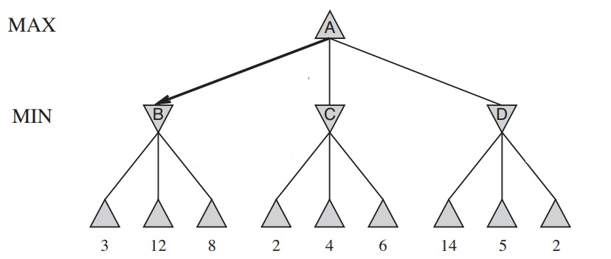  ii) apply alpha-beta pruning on the below diagram  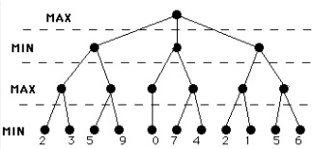 | L3 | CO1 | [8M]
 | OR
10 | Evaluate Greedy Best-First Search and A* Search on the same problem. Which one performs better and why?  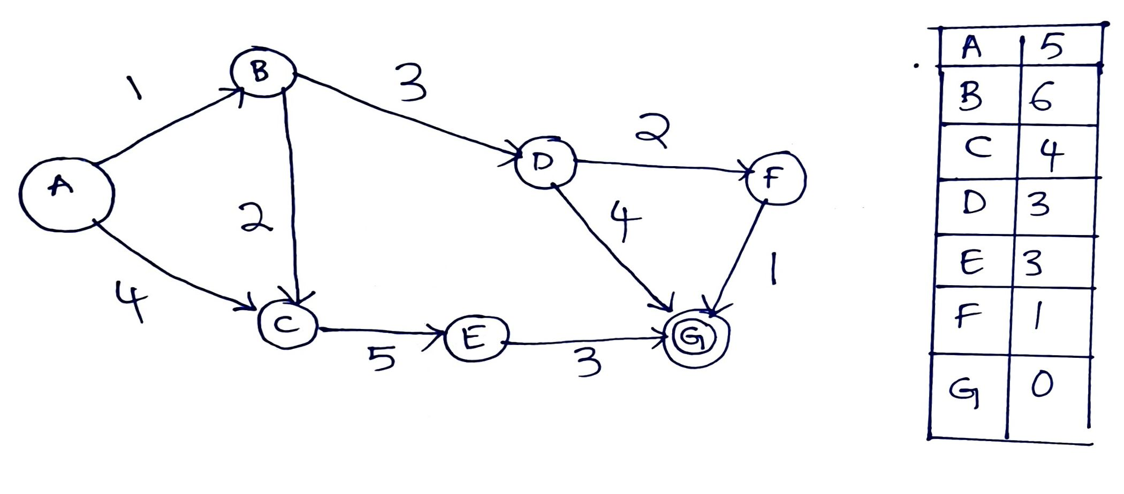 | L5 | CO1 | [8M]
11 | i) Define first-order logic and describe its syntax and semantics with examples?  ii) Evaluate the limitations of propositional logic in comparison to first-order logic? | L2 | CO2 | [8M]
 | OR
12 | Demonstrate the use of unification and lifting in first-order inference with an example? | L3 | CO2 | [8M]
13 | i) Analyze how value of information helps in making better decisions?  ii) Describe the role of utility theory in AI decision making under uncertainty. | L4 | CO3 | [8M]
 | OR
14 | i) Evaluate the challenges in reasoning under uncertainty in partially observable environments?  ii) Analyze how partial observability affects decision-making in MDPs. | L5 | CO3 | [8M]
15 | Describe the architecture of a Convolutional Neural Network (CNN) and its key components? | L2 | CO4 | [8M]
 | OR
16 | Evaluate the performance of a CNN model on the CIFAR-10 dataset. What metrics would you use? | L5 | CO4 | [8M]
17 | Define Markov Decision Process (MDP) and explain its components with a diagram? | L2 | CO5 | [8M]
 | OR
18 | Apply Q-learning to a grid-world problem and explain the learning process?  Consider the following 4x4 Grid World environment where an agent wants to reach the goal state G starting from the start state S. The agent can move in four directions: Up, Down, Left, and Right. The agent receives a reward of -1 for each move and +10 for reaching the goal state.  - The agent cannot move outside the grid.  - The agent starts at state S = (0,0) and wants to reach G = (3,3).  - Use the Q-learning algorithm with learning rate α=0.1\alpha = 0.1α=0.1 and discount factor γ=0.9\gamma = 0.9γ=0.9. | L3 | CO5 | [8M]
  (0,0) S | (0,1) | (0,2) | (0,3)
  (1,0) | (1,1) | (1,2) | (1,3)
  (2,0) | (2,1) | (2,2) | (2,3)
  (3,0) | (3,1) | (3,2) | (3,3) G

-- 00 -- 00 –

